Tariff Issue

* January 1st 2019, material costs increased by 20%,
* Difficult to guarantee the material costs (for contractors) 🡪 clients nervous about the change of prices (MAYBE WE CAN INTEGRATE BLOOMBERG AND SUCH MATERIAL DATASET LIKE BASIC FORECASTS ABOUT MATERIAL COSTS IN AN OPTIONAL WAY, IN 3 MOTHS THERE FORECASTS ARE SAID THAT…)

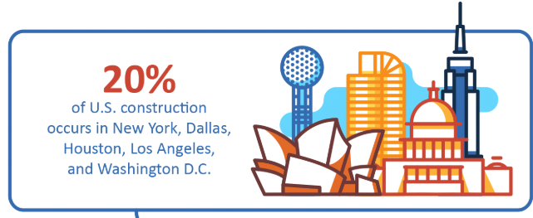

{MAYBE OUR FIRST TRIAL LOCATIONS}

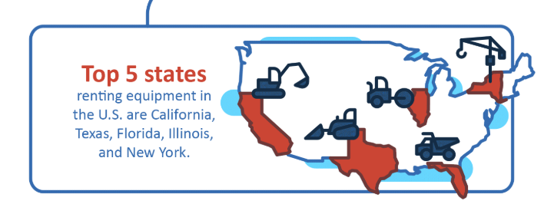

1. Last year saw a 12% growth in the number of construction firms using Building Information Modeling (BIM) software. [[NBS](https://www.thenbs.com/knowledge/the-national-bim-report-2018)] – 2018 DATA {DISRUPTIVE TECHNOLOGIES ARE GROWING}

82% of contractors agree that BIM (Building Information Modeling) is the future of project information. [[NBS](https://www.thenbs.com/knowledge/the-national-bim-report-2018)] – 2018 DATA

90% of all global infrastructure projects are either over-budget or delayed. [[FMI](https://www.fminet.com/wp-content/uploads/2018/01/Overview2018_FINAL-1.pdf)] – 2018 DATA

*MOST CONTRACTORS AND SUBCONTRACTORS USE DIFF TECHNOLOGIES DON’T ALWAYS COMMUNICATE EACH OTHER

More than 250 million open construction jobs exist in US Construction and news, continue to grow. {OUR SYSTEM INCREASE THE EFFICIENCY OF GENERAL PROCESS BECAUSE IN GENERAL MUCH MORE COMPETITIVE FIELD SCARCE RESOURCES}

STAGNANT PRODUCTIVITY LEVELS {THANKS TO OUR SYSTEM, WE CAN CREATE MORE EFFICIENCY RATIOS COMPARED THE HISTORY} 🡪 steady decline in productivity since 1960s.

MARKET SHARE {TOTAL MARKET DATA}

* One of largest in world economy {construction sector}
* $10 trillion spent every year globally
* Sector’s annual productivity growth only increased 1% over past 20 years

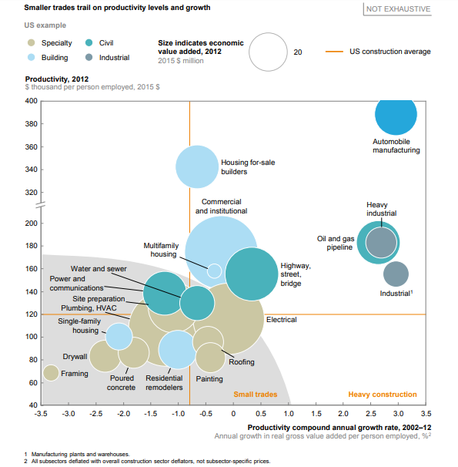

{PRODUCTIVITY PROBLEM IN FIELD ESPECIALLY ABOVE PIC}

SURVEY PERFORMED BY 



{CAN BE OUR KEY PARTNERS}

Utah Integrated Technology in Architecture Collaborative construction industry professional database of 23,000 contacts.

In both the 2018 and 2014 surveys, respondents delineated the perceived and realized benefits of off-site construction to project performance. The primary benefit identified in both surveys is a reduced overall project schedule, specifically the duration of the construction phase. Other realized benefits noted from the survey include the quality of the product and cost effectiveness (Questions 4 and 5, 2018; Questions 5 and 6, 2014).

According to 78% of respondents, off-site construction requires moderately higher or significantly higher levels of stakeholder engagement.

Construction culture and late design changes were the most significant barriers (Question 2, 2018).

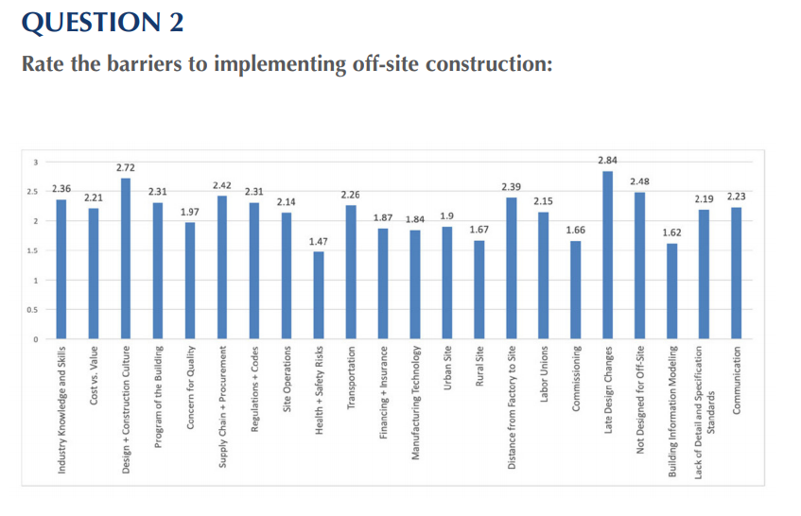

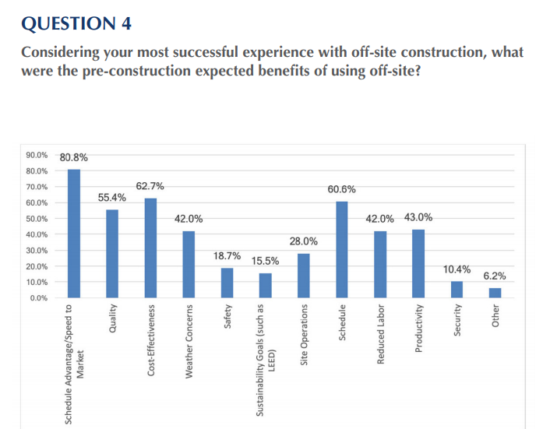

<https://cdn.ymaws.com/www.nibs.org/resource/resmgr/oscc/oscc-2018surveyreport.pdf>